Fiona Castle, Chief Officer

Swindon & wiltshire LPC   
 6, St John’s Road, Wroughton, Swindon SN4 9ED

Annual report

2017-18

# Chair’s Report

It’s been another challenging year: navigating the government cuts, dealing with increasing cost base, new bureaucracy e.g. quality payments (QP), medicines supply shortages, increasing online competition, brain drain into general practice and uncertainty around Brexit.

During the year, your LPC have supported QP with health champion training, engagement support from Ilyas, information / signposting via Lis’s newsletter and emails. Your committee have been lobbying MPs, appearing on TV (e.g.: Zoë Pearce’s debut on *Countryfile*), accepted invitations for radio interviews, local and national, and personally as a key witness in both the NPA judicial review and the subsequent appeal. All of which contribute to the ongoing public debate around how NHS spending in pharmacy will be best spent to improve patient care. As the PWC report concluded, £1 spent in community pharmacy saves £23 spent elsewhere in the health economy. Our voices are, and continue to need to be heard.

Despite this climate our patients remain loyal and committed to their local community pharmacies. Those that dabble in online services soon return when the service doesn’t come close to their own local pharmacy.

A highlight this year was the inaugural local community pharmacy awards. They showcased the local expertise in our community, maintaining local recognition for the importance of our service to patients. Well done to Zoë, Fiona, Lis and Chris for making this a great success.

I’d like to turn to the future. In my view there is inequity between the treatment of small and large business and in particular global tech giants. Traditional retailers face a much higher tax burden than their online rivals. As a stark example, the Amazon UK corporation tax bill was £4.6m last year on UK sales of £9bn and this equated to the business rates on just one of House of Fraser’s 59 outlets. Technological advances including AI continue apace; this of course brings the prospect of great advantages. To master the game of Go, Deepminds’ AlphaGo used machine learning to decimate the Go world champion Ke Jie. However, AlphaGo wasn’t able to display a jot of empathy or compassion for the distraught Ke Jie and has yet to create anything beyond its expertise in the game Go.

So community pharmacy must be creative and adapt. Community pharmacy must remain an oasis for empathy and compassion. Community pharmacists will need to use their creative élan and alacrity to offer patients ‘sticky’ products and services. The mainstay of such adaptation must surely centre around independent pharmacist prescribing which has long been a strong strategic thread in all my time at the LPC, and is at the heart of the current committee’s vision.

I retire as Chair this year after 4 eventful and rewarding years and hand over to Vice-Chair Chris Shields who I thank for all his hard work and support; the Committee is in safe hands under his leadership. Also, I would like to thank all the committee for their hard work and in particular Fiona and Lis for their tireless support of the committee. Robert has once again grappled admirably with the finances, which too is much appreciated.

My best wishes to all in Community pharmacy.

Nick Jephson  
Chair, 2014-18

Current Chair’s statement

As we take our steps into the new four-year term I am heartened to know that the committee members sitting with me are truly passionate in promoting and enhancing community pharmacy and doing their upmost for the contractors they represent. I would like to thank my predecessor Nick Jephson for his steadfast leadership of the committee over the last four years. His unwavering belief and passion for community pharmacy has certainly inspired me to continue his work and drive our agenda forward. I would also like to thank the members of the committee and our employees for their wisdom and patience, both of which I will call on time and time again.

I feel that Community Pharmacy Swindon & Wiltshire is in rude health to work towards our vision. The vision is ambitious, as I and my colleagues feel that for Community Pharmacy to thrive we need to be bold. We need to look to new horizons and enhance our service offering to benefit patients, the NHS and contractors alike. In this uncertain climate we need to grasp opportunities in a proactive manner and those opportunities may not present themselves from traditional sources. Our four workstreams have been designed so that the committee can be proactive in seeking these opportunities and that also when they do arrive that we can action them swiftly and efficiently.

The vision we have will not come without hard work, determination and belief. It will also not happen overnight. Pharmacy has a lot to offer the public and the NHS and I want this current term to be about the ‘what we can do’. As a profession we sometimes sell ourselves short and overcomplicate problems which invariably prevents progress. I want my time as the Chairman of CPSW to be one of positivity. I firmly believe if we work collaboratively and with a ’can do attitude’ then anything can be achieved. I invite all contractors and staff of community pharmacy in Swindon and Wiltshire to engage with CPSW and come on the journey which will keep pharmacy at the heart of every community.

Chris Shields  
Chair, 2018 -  
Community Pharmacy Swindon & Wiltshire

# Chief Officer Report

## Key activities and achievements 2017-18

Stakeholder Engagement

* Steve Maddern (public health, Wiltshire) and Ayo Oyinloye (Public Heath, Swindon) engaged the committee with the STP roll-out of the National Diabetes Prevention Programme
* Committee members engaged with prospective parliamentary candidates in the run up to the General Election
* Members worked together on developing an “Elevator Pitch” to assist in the explanation of the LPC role during brief meetings with stakeholders
* The committee maintained an interest in and support for “POD” – the CCG hosted prescription ordering telephone services in both Swindon and Wiltshire
* Fiona Castle and Aga Janowska participated in the AHSN Quality Collaborative with a view to promoting improved relationships between GP Practices and Pharmacies in Trowbridge
* LPC members and pharmacists were encouraged to attend multi-disciplinary diabetes forum meetings in Swindon to support mutual understanding
* GPhC attended an LPC meeting as part of the consultation on revalidation for pharmacy professionals
* LPC members influenced the materials available to pharmacies from the NPA for “Ask Your Pharmacist Week” and encouraged participation
* A good selection of guests engaged with LPC meetings, including representatives from Wiltshire CCG medicines management team, Tess Green – director of Transformation for Swindon CCG, representatives of public health in both Wiltshire and Swindon, NHS Smartcard team manager
* Relationships were built with Medvivo to explore effective Urgent Care working
* Close working with the Directory of Services team facilitating improved communication regarding referrals from NHS111 to pharmacy
* Relationships with Turning Point were maintained and grown as they were appointed Drug and Alcohol service provider across both Swindon and Wiltshire
* Zoë Pearce responded to call for a local pharmacist to appear on “Countryfile” regarding flu

Contractor Support

* HLP training was provided to support both leadership and Health Champion elements using monies which had previously been held for public health initiatives
* HLP Evidence Folders were prepared and distributed to pharmacies who requested support
* An Awards Ceremony was organised to recognise the great work going on in Community Pharmacies locally
* The LPC arranged the option of PharmOutcomes or Spreadsheet data collection for the PNA contractor survey and collated the results to ensure useful, accurate information was considered in the PNA with minimum workload for contractors
* Support Officer engagement ensured 100% CPAF completion, almost 100% contractor response for PNA Contractor Survey and elements of Quality Points for contractors who were otherwise uncertain about criteria
* Input and feedback to Wiltshire POD regarding call handler scripts and GP communications to patients
* Applications for NHS mail accounts required support – some applications straightforward, others confusing and trouble-shooting required.
* Guidance around appropriate use and prescribing intervals for MDS was revised and recirculated
* LPC responded to consultations on pregabalin/gabapentin reclassification – noting that reclassifying as Controlled Drugs which required safe custody would incur costs which would outweigh benefits
* A Diabetes training event was organised with support from Astra Zeneca
* Funding from AHSN was used to support work by Support Officer encouraging pharmacy staff to pick up and act on discharge summaries and other referrals from our local hospitals. Feedback from those that act on these referrals is that they are very useful.

Service Development

* Diabetes related services were explored with some interest from both Commissioners and Pharmaceutical Industry
* Support was provided to Great Western Hospital in the development of the revised PGDs for Emergency Oral Contraception, especially appropriate wording to satisfy responsibility for the competence of pharmacists working to the PGDs
* Support and co-ordination of occupational health flu vaccination for Wiltshire Council through Community Pharmacy was again provided
* Wiltshire Council accepted an LPC proposal around Naloxone Supply. Work progressed to agree a formal SLA and contractual arrangements
* A Strep B test and treat service was proposed, but not of interest to commissioners at the time
* Work started with Turning Point to agree an alcohol brief intervention service

Provider Company

* The Provider Company lay dormant as proposed in its initial formation

Other Notable achievements and events

* Zoë Pearce, Lis Jardine and Fiona Castle co-ordinated the first LPC Awards Ceremony
  + Zoë secured a video message from the new Minister responsible for Pharmacy!
  + We had many examples of the excellent work going on in our local Community Pharmacy teams

## 

## Community Pharmacy Service Delivery

Essential Services

The contribution to pharmacy income from dispensing fees stabilised, but at a lower level than in previous years

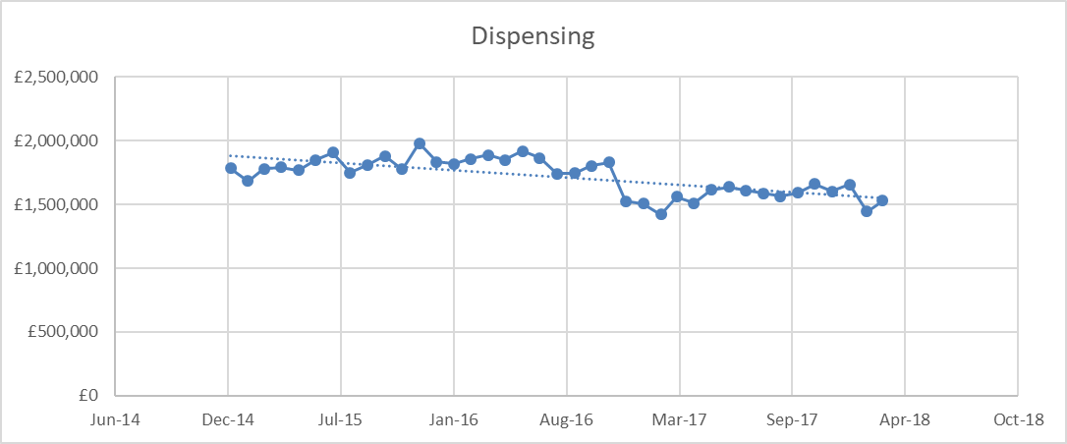

* Ordering of Repeat Medicines
  + Members of the Local Pharmaceutical Committee continued to work closely with the “POD” (Prescription Ordering Direct) schemes of both Swindon and Wiltshire CCGs. There have been issues with patient and GP Expectation in Wiltshire. Capacity issues arose in Swindon. Improvements have been made and engagement with the schemes remains positive
* There have been changes to (reductions in) opening hours as pharmacies react to reduced funding

Advanced Services

Engagement with MUR and NMS and Seasonal Flu vaccination has continued to grow steadily.

NUMSAS – The NHS Urgent Medicines Supply Advanced Service was introduced in Wiltshire in October 2017 and later in Swindon. The service has been used over 300 times.

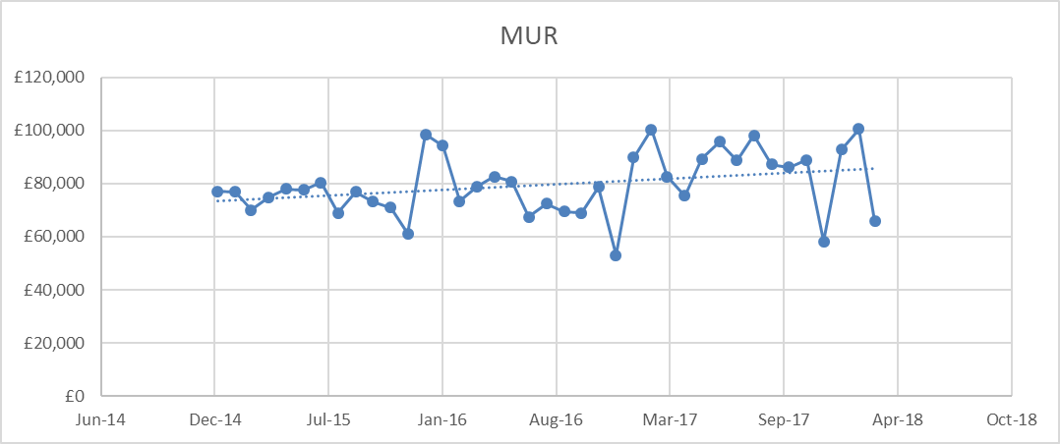

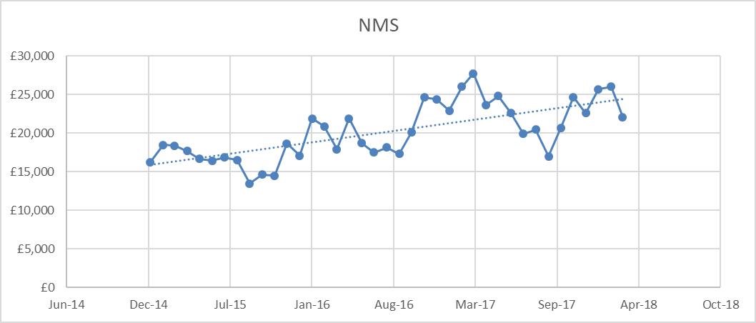

Participation in Seasonal Flu vaccination grew with 12496 NHS vaccinations delivered in Community Pharmacy in the 2017-18 season compared with 7214 in 2016-17

Quality Points

2017 saw the introduction of the Quality Points Element to Community Pharmacy Funding.

78 pharmacies claimed all available points

3 Current pharmacies claimed zero points; one is likely to be a data anomaly due to recent change of ownership; one has no consultation room; one is a specialist distance selling provider which is minimally engaged with the NHS element of its pharmacy supply.

There does not appear to be any LPC support requirements for these pharmacies

At £64 per point, funding of £736,000 was available in the area. £670,240 was claimed. Slightly more was paid out due to balancing payments.

The LPC supported contractors through

* Organisation and provision of training to support Healthy Living Pharmacy status
* Checking on status of NHS Choices information and providing feedback where action was required
* Checking on SCR Access status and assisting in resolution of access issues
* Checking on nhs.net email status and assisting where required to resolve access issues

Transfer of Care Initiative

The LPC has been working with the local secondary care pharmacy departments, supported by the West of England Academic Health Science Network, to transfer appropriate discharge information and referrals to Community Pharmacy.

*Introduction*

Swindon and Wiltshire LPC encouraged the pharmacy teams in RUH Bath and later in Salisbury Foundation Trust to communicate the detail of patients discharged with “Dosette Boxes” via PharmOutcomes.

The same templates were used across both hospitals, and were based on the templates used in Bristol/Avon

This report covers the full duration of the project to date (24/7/18). Referrals started from RUH (Bath) on 8/11/16. Referrals from SFT (Salisbury) started on 31/7/18.

All referrals must be manually entered onto the PharmOutcomes system by pharmacy staff. The SFT pharmacy department are exploring an option which would allow integration with the hospital prescribing system.

*Key Statistics*

Records include 637 referrals from RUH and 212 from SFT

Of the 949 records analysed:

* 903 were acknowledged by the pharmacy;
* 849 have feedback associated with them (ie the pharmacy marked the record as complete)
* 740 were reported as “useful” by the pharmacy
* **610 cases indicated that the information prevented waste**

In 16 cases where the pharmacy reported why the referral was NOT useful, the comments can be categorised as

* Too late (e.g. received 1-2 weeks after discharge) (7)
* Patient deceased or returned to hospital (4)
* The information had already been received by another route (1)
* The discharge summary received was not the current/latest one (1)
* The information was not complete (discharge summary not attached) (2)
* No changes to the medication (1)

*Supporting pharmacy engagement*

Checking for these documents is an additional task for Community Pharmacy teams, and required a change in culture. This has been supported by the LPC Support Officer making calls to pharmacies who had unacknowledged referrals

104 calls were made to 37 different pharmacies to support this service.

## Locally Commissioned Services

### Value

|  |  |  |  |
| --- | --- | --- | --- |
| Service | Turnover – Wiltshire | Turnover – Swindon | Total |
| Sexual Health | £11899.81 | £5829.89 | £17,729.70 |
| Supervised Consumption | £81270.00 | £95845.00 | £177,115.00 |
| Needle Exchange | £6496.93 | £16056.49 | £22553.42 |
| Stop Smoking | £15528.86 | £26209.69 | £41,738.55 |
| NHS Healthchecks |  | £7620.00 | £7620.00 |
| Urgent Repeat Medicines |  | £21425.92 | £21,425.92 |
| Flu Voucher Scheme | £1812.00 |  | £1812.00 |

Total turnover value of locally commissioned services: £292,978.40

### Spread/Availability

#### 1. Sexual Health Services

This is mainly consultations related to the supply of Emergency Hormonal Contraception. Also included are very small volume and value services including chlamydia testing or treatment and condom distribution. Some pregnancy testing is done in Wiltshire

29 pharmacies declared some activity in these services during 2017/18 of which only 14 carried out more than 1 consultation per month on average

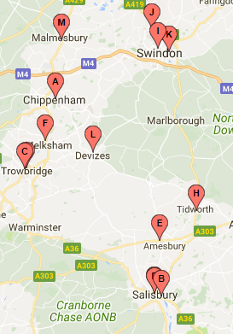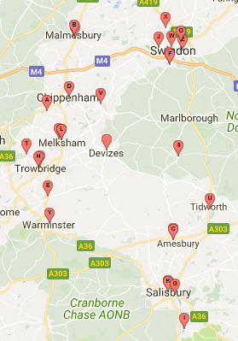

Higher Activity

Some Activity

#### 2. Supervised Consumption

90 pharmacies provided this service during 2017-18 of which 63 appear to provide the service to more than one client on a regular basis

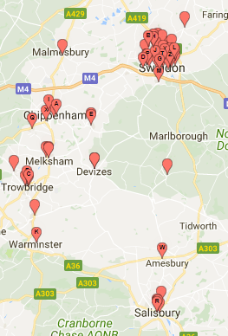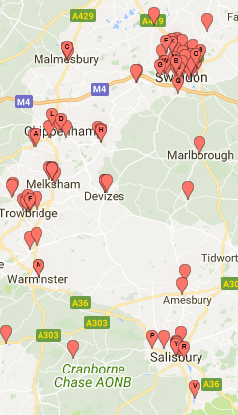

Higher Activity

Some Activity

#### 3. Needle Exchange

39 pharmacies provided this service of which 28 make more than 2 exchanges per week on average

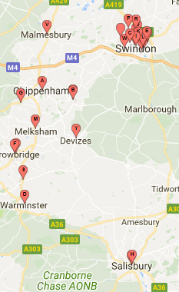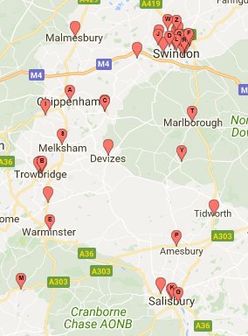

Higher Activity

Some Activity

#### 4. Stop Smoking

41 pharmacies recorded the recruitment of smokers to their Stop Smoking Service during 2017-18. However numbers of clients recruited and quit rates are very low. Only 20 pharmacies recruited more than 10 clients throughout the year

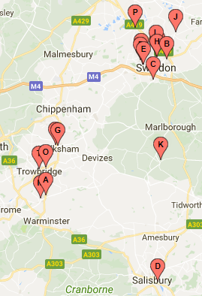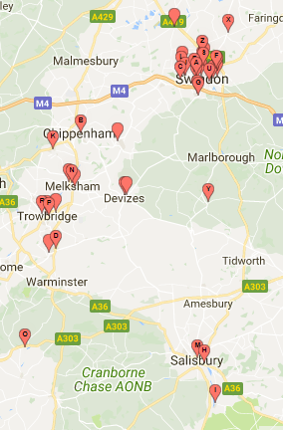

Some Activity

Higher Activity

#### 5. NHS Healthchecks

This service is only commissioned in Swindon. 10 pharmacies reported activity with only 4 providing more than 1 check per week on average

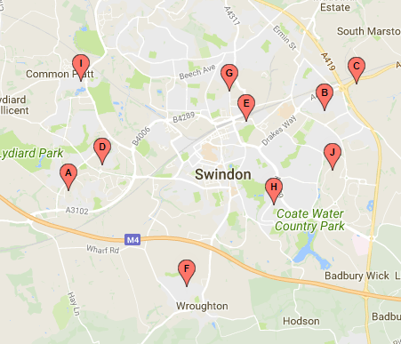

Some Activity

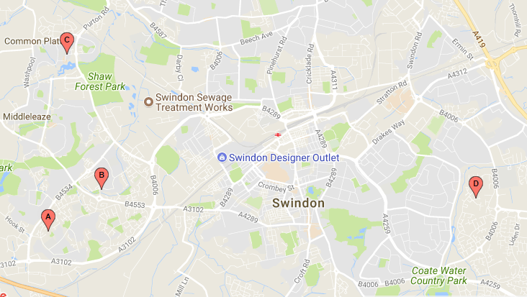

Higher Activity

#### 6. Urgent Repeat Medicines Service

This is only commissioned in Swindon (all activity in Wiltshire is through the nationally commissioned NUMSAS which is only available to patients who have rung NHS111)

30 pharmacies reported activity during 2017-18, of which 8 were very active (more than 1 supply per week), 13 recorded very low activity (less than 1 supply per month) and 9 reported between 12 and 60 supplies during the year.

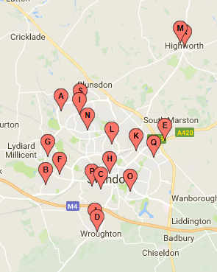Very active pharmacies All active pharmacies

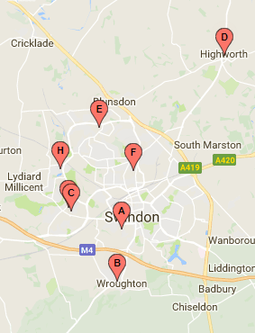

#### 7. Flu Voucher Scheme

This is only commissioned by Wiltshire Council (however they have commissioned at least one Swindon pharmacy to deliver the service as a number of eligible clients live in Swindon and find it more convenient to access their local pharmacy.)

22 pharmacies delivered the service in 2017-18, with only 4 providing more than 10 vaccinations under the scheme. Higher volume pharmacies reflect proximity to council premises with significant numbers of employees

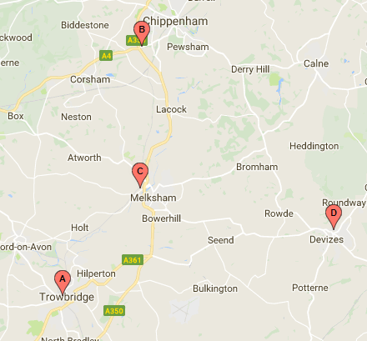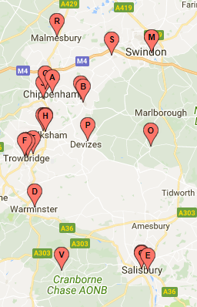

Higher Activity

Some Activity

# Communications Officer report

My highlight this year was helping to organise the inaugural Community Pharmacy Awards which took place in February 2018. We had some wonderful nominations and I felt very privileged to receive and read them. The event itself could have been better timed – a number of attendees didn’t make it due to the freezing weather – but it was a fantastic celebration of pharmacy’s strengths and success. Thanks to everyone who helped make it happen, most of all the hard-working pharmacy staff in Swindon & Wiltshire. You guys are fantastic!

I have used Mailchimp exclusively this year to send out bulletins, messages and news. I currently maintain two mailing lists – one a collection of personal, organisational and store email addresses we have collected over the years, and one for the new NHS.net shared mailboxes. The stats show:

|  |  |  |
| --- | --- | --- |
| **Recipients** | **Average open rate %** | **Average click rate %**  (following a link in the email) |
| Swindon collection (59 contacts) | 16.9 | 4.5 |
| Wiltshire collection (133 contacts) | 12 | 3.5 |
| Swindon NHS.net (49 contacts) | 4.2 | 1.5 |
| Wiltshire NHS.net (69 contacts) | 6.1 | 3.9 |
| Owners and Multiple Managers (38 contacts) | 22.2 | 4.8 |

Obviously we’d love to see higher figures here – remember, we don’t send out a message unless it tells you something you need to know! One possibility is that in future the LPC uses only NHS.net addresses to communicate with pharmacies (as does NHS England). This would resolve a number of current difficulties such as named personnel moving or leaving stores, and certain stores (*cough*Boots*cough*) rarely opening their organisational store mailboxes.

In January I re-designed the newsletter to create a fresh new look; as usual, I have received little feedback from readers, but I trust that you do read them. They’re the best way we have of supporting you with information you might have missed (especially if you don’t open your bulletin emails…)

On Twitter, the #pharmacyconfidential campaign continues with regular tweets as below:

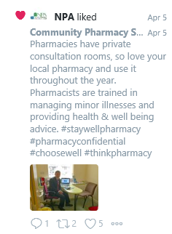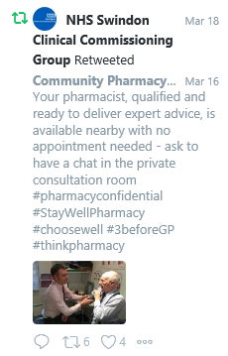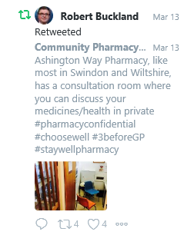

We are tending to get more and more likes for these messages as we accrue more followers. The campaign has fitted very well alongside the ‘Stay Well Pharmacy’ publicity generated by NHS England.

Another enjoyable task this year was to rebrand the LPC to ‘Community Pharmacy Swindon & Wiltshire’, launching a new logo and updating all our visual communications in April 2017. We hope our new name, along with a new vision, will enable people both in and outside of the NHS to understand what our committee is for, and how we aim to achieve our goals.

Lis Jardine  
Communications Officer

# Support Officer Report

Ilyas Piperdy supported the committee and local pharmacies through targeted calls to pharmacies, for example highlighting action required for Quality Points, or to support the local Transfer of Care initiatives.

# Plans for 2018-19

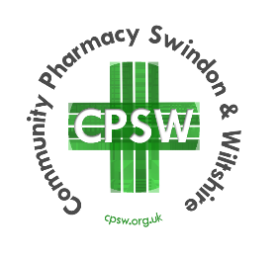April 2018 sees the start of a new committee four-year term. Members have taken this opportunity to refocus on the purpose and vision of the organisation.

We have rebranded as “Community Pharmacy Swindon and Wiltshire” and renewed our purpose and vision:

***Purpose:*** *Community Pharmacy Swindon and Wiltshire is made up of members with diverse backgrounds and different skill sets coming together to support and encourage contractors to fulfil their potential*

***Vision:*** *A network of Healthy Living Pharmacies, supported by Pharmacist Independent Prescribers, delivering accessible, holistic healthcare services to patients*

Activities and objectives will be themed in the following workstreams:

* Leadership
* Building Relationships
* Service Sustainability
* Service Development

# Member Attendance



# Accounts



## Swindon and Wilts LPC Member’s Expenses April 2017 to March 2018

|  |  |
| --- | --- |
| MEMBER’S NAME | TOTAL EXPENSES |
| Paul Hedge | £1785 |
| Andrew Hobson | £437 |
| John Hughes | £1015 |
| Sai Jammigumpula | £1711 |
| Aga Janowska | £2309 |
| Nick Jephson | £3563 |
| Kaushik Patel | £1433 |
| Will Pearce | £149 |
| Zoe Pearce | £2769 |
| Arvinder Sagar | £618 |
| Chris Shields | £3158 |
| Robert Townsend | £4122 |
| Sian Williams | £2314 |
| Charlie Wu | £863 |

Robert Townsend  
Treasurer